Contents

Step 1: Adding the RFM Segmentation Solution to Dataiku 1

Step 2: Creating an App Instance in Dataiku 1

Step 3: Configuring the App Instance 2

RFM SOLUTION (SNOWFLAKE-DATAIKU)

## Step 1: Adding the RFM Segmentation Solution to Dataiku

1. In the Dataiku Launchpad, navigate to **Dataiku Solutions** and click on **Add a Dataiku Solution**.
2. In the search bar, type **RFM Segmentations**, select the solution, and click **Install**.

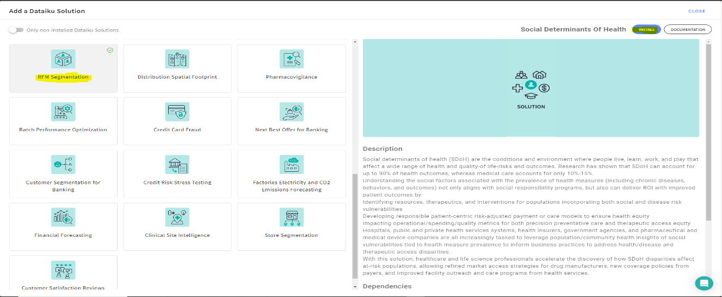

## Step 2: Creating an App Instance in Dataiku

1. Go to the **Dataiku Home** page and navigate to **Applications**.
2. Click on **Create App Instance**, then give your new instance a name.

## Step 3: Configuring the App Instance

1. Open the app instance you just created.
2. In the **Input Field**, select the main **Connection Type** (e.g., Snowflake). Choose the relevant **Table Name** from the available options. Ensure the table exists in the connection, then click **Configure**. A success message will confirm if all settings are correct.

1. Move to the **Transactions Preprocessing** section and select the columns required for identification.

1. Finally, go to the **Build All Flow at Once** section, then click **Build**. This will initiate the RFM segmentation process.A white rectangular object with a black border

   Description automatically generated